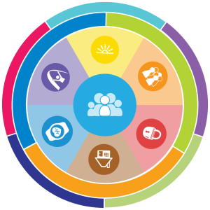
Safety-Care Training
for Families
Presented by Department of Human Services

Safety Care Trainers Brooke Nelson and Carrie Geppert

What is Safety Care?

Safety-Care® Behavioral Safety Training program provides the skills and competencies necessary to effectively prevent, minimize, and manage behavioral challenges with dignity, safety, and the possibility of change. Safety- Care training can help you:
- Understand how and why crisis events happen and how we may inadvertently contribute to them
- Prevent crises using a variety of supportive interaction strategies
- Apply simple, evidence-based de-escalation strategies
- Respond appropriately and safely to dangerous behavior
- Prevent the need for restraint
Who should attend the training and is there a fee?
Family members and others who may provide in-home support for individuals
with an intellectual or developmental disability. There is no cost to attend, however space is limited, and registration is required.

- Intervene after a crisis to reduce the chance for reoccurrence

Tuesday, August 17th, 2021
From 4:30-7:30 PM

Siouxland Library - Caille Branch
4100 Carnegie Circle, Sioux Falls

How to register:
Contact Brooke Nelson at Brooke.Nelson@state.sd.us or 605-688-5103

Still have questions?
Contact Carrie Geppert at Carrie.Geppert@state.sd.us or 605-362-4857

