Why it is important to vote 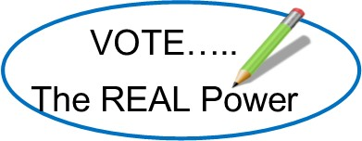

South Dakota Absentee Voting began on September 18. 2020. During the current pandemic, it is just as, if not even more important, to vote in the 2020 general elections. Individuals with underlying health issues, disabilities and senior citizens are at the highest risk for becoming ill.

So why should you vote? One simple reason—if you do not vote you give up the right to have your voice heard. Some people do not vote because they do not like any of the candidates or understand the ballot questions. They may think their vote does not matter. When a person does not vote they are letting those who do vote choose who will be their voice.

Sadly, the voices of individuals with disabilities are not heard as well as they should be. People with disabilities do not vote as much as others. The voice of all individuals is equally important. People with disabilities need to find and vote for candidates that have the same ideals and goals as they do.

To remain safe and still exercise your right to vote you can fill out an absentee ballot application. It can be printed from the Secretary of State’s website at https://sdsos.gov/ . You can also contact your local county auditor and request an absentee ballot application be mailed to you.

Absentee ballots applications must have a copy of a photo ID or be notarized. If you do not have access to a copier or notary, a picture of your photo ID can be taken and sent to your County Auditor via text or email. All County Auditor information is available at the Secretary of State’s website at https://sdsos.gov/.

You MUST sign the outside of the envelope provided by the County Auditor’s office prior to mailing.

In South Dakota, the County Election Official must receive your application for absentee ballot no later than 5 p.m. the day before the election.

